Collagen fibre orientation was desired to be able to identify the level to which wounds recovered their natural structural components during the wound healing process. To undertake this, we developed a MATLAB code which first isolated collagen fibrils from non-fibrous tissue using a colour-based segmentation algorithm. First, the user selected image is converted from an RGB image to a two-dimensional matrix of type . Where and represent the row and column indices respectively. Our code (which we name FIBRAL) converts the image colour space from RGB to L*a*b to more accurately predict small colour differences [1] – key in picrosirius red (PSR) staining in which small variation detection is required. Both the full a-channel and positive range of the b-channel were isolated and superimposed. This new matrix was transformed into grayscale with contrast and brightness increased by 20% and 5% respectively.

To determine the spatial distribution of collagen fibres, a two-dimensional Fourier transformation was performed on the image. This data was transformed from cartesian to polar coordinates by grouping predominant frequency-component orientations of the fibres in 1-degree increments from 0 to 180 degrees. The total intensity at each angle was calculated by summing the grayscale intensity values of each pixel contained within the group. Large intensity values represented the summation of multiple sinusoidal waves with large amplitude signifying major fibre alignment along the respective orientation. From this data, a comparative analysis can be conducted whereby the dot product was calculated using each permutation of resulting vectors (parallel vectors would provide a dot product of 1, with orthogonal vectors presenting a dot product value of -1). All results were normalised to lie between 0 and 1 with a directionality quotient of 1 representing a parallel field of fibres and a directionality quotient of 0 representing full fibre orientation across all angles in the tissue. The code was validated against images with dominant fibre orientations and combinations thereof. Full details of the coding approach are included in the supplementary material.

# References

|  |  |
| --- | --- |
| [1] | D. J. Bora, A. K. Gupta and F. A. Khan, "Comparing the Performance of L*A*B and HSV Colour Spaces with Respect to Color Image Segmentation," *International Jounral of Emerging Technoligies and Advanced Engineering,* vol. 5, no. 2, pp. 192-203, 2015. |

# Appendix A: Calculation of an alignment coefficient for isotropy analysis

To determine the alignment of collagen fibrils within the PSR stained images, the L*a*b enhanced image was transformed to the frequency domain using a two-dimensional Fourier transform. A frequency shift was performed to centrally contain low frequencies, with higher frequencies distributed radially. The resultant image was then transformed from cartesian to polar coordinates. To transform the image, a horizontal line, positioned from the central axis, was superimposed onto the original image. All pixels contained within the line were grouped and represent the intensity of the sinusoidal waves required to characterise all fibrous tissue oriented at degree from the horizontal axis. The line was then redrawn from to degrees at a 1-degree bin size, with all remaining pixels placed within one of the 180 groups. The total intensity at each bin size was calculated by summing the grayscale intensity values of each pixel contained within the group. Large intensity values represented the summation of multiple sinusoidal waves with a large amplitude; signifying major fibre alignment along the respective orientation.

To generate a quantifiable metric which describes the level of isotropy present in a collagen fibre matrix a two-dimensional array is created which stores the overall intensity value at each one-degree bin size:

Where and relate to the angle and intensity values at each 1 degree bin size. To analyse the directionality of the fibre distribution, we create a direction vector at each 1 degree bin size with a magnitude equivalent to the summed intensity value of the pixels:

From this, a comparative analysis can be conducted whereby the dot product is calculated using each permutation of two vectors:

In this case, parallel vectors would provide a dot product of 1, with orthogonal vectors presenting a dot product value of -1. After completion of the above phase, all results are normalised between 0 and 1. All segments are then averaged to give an overall directionality quotient:

A directionality quotient of 1 represents an ideally linear case, where all fibres are oriented along one primary angle. A directionality quotient of 0 represents ideal isotropy where an equal proportion of fibres are oriented across all angles.

# Appendix B: Exemplar image transformation for fibre isolation

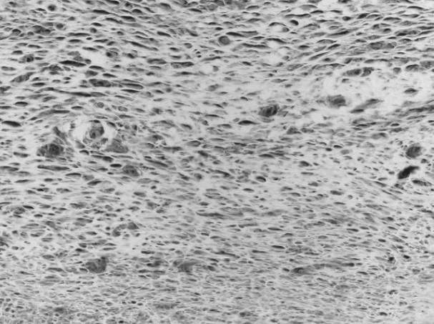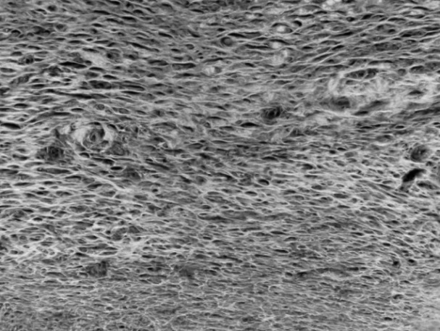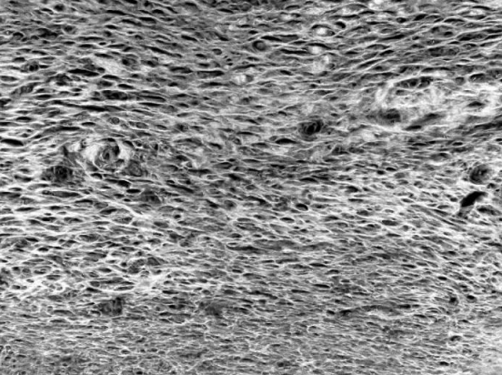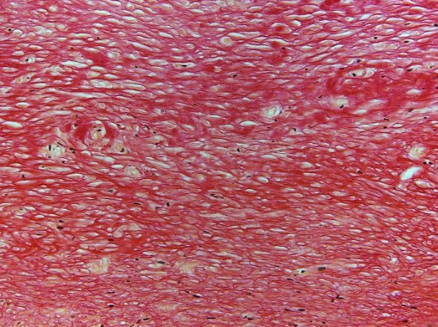

1. Base Image

(E1) a-channel

(E2) a-channel combined with +ve b-channel

(E3) Combined Channels and Image Enhancement

Figure 1: Progression of image preparation algorithm showing improved fibre clarity. (D) - base fibrous image. (E1) – a-channel isolation after L*a*b conversion. (E2) – combination of a-channel with +ve region of b-channel. (E3) – combined channels with contrast and brightness adjustment